rank() Problems: University DB

- O/P top salaried instructors along with their rank.

- O/P top salaried instructors along with their rank and department.

- Students along with their credits ordered by their rank.

- Department along with the number of instructors teaching there, order the output by rank.

- Avg salaries of departments ordered by their rank where avg salary of a department is greater than 100000.

1
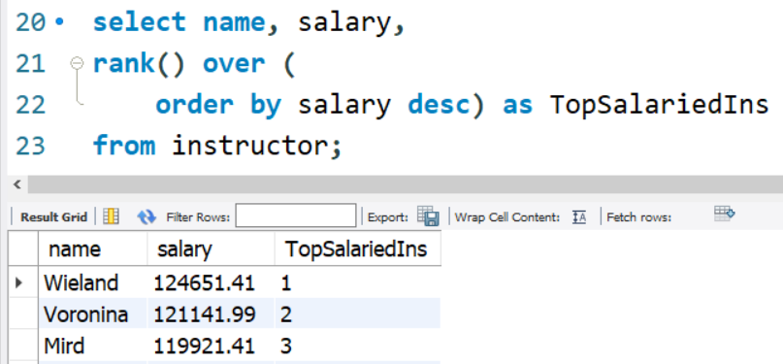

3
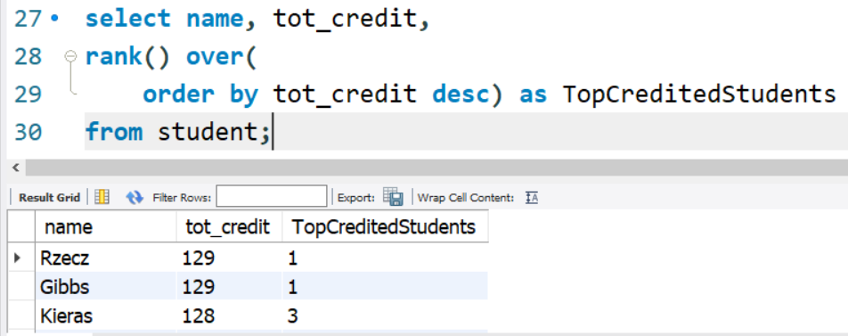

4
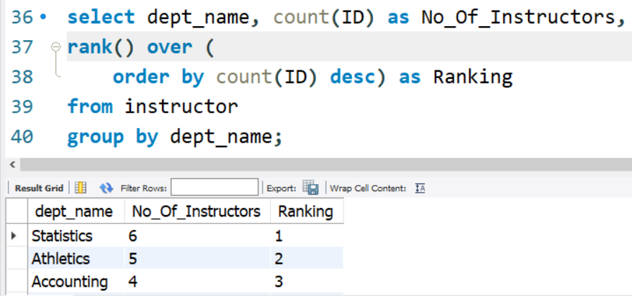

5
